369ai
H R S U I T E F O R O D O O 1 9
ATTENDANCE LATE TRACKING
HR Step-by-Step Guide

Grace periods, deduction slabs, waivers, split shifts and half-day Fridays — a fair, configurable late policy.
A simple guide to setting up the late policy, reading late records, approving waivers and running the monthly summary.

PART 1 FINDING LATE TRACKING

1 | Open the Late Tracking menu

Everything lives under Attendances → Late Tracking. From there you reach Late Records, Monthly Summary, Waiver Requests (or My Waiver Requests for staff), and a Configuration group with Office Hours & Working Days, Deduction Slabs and Public Holidays.
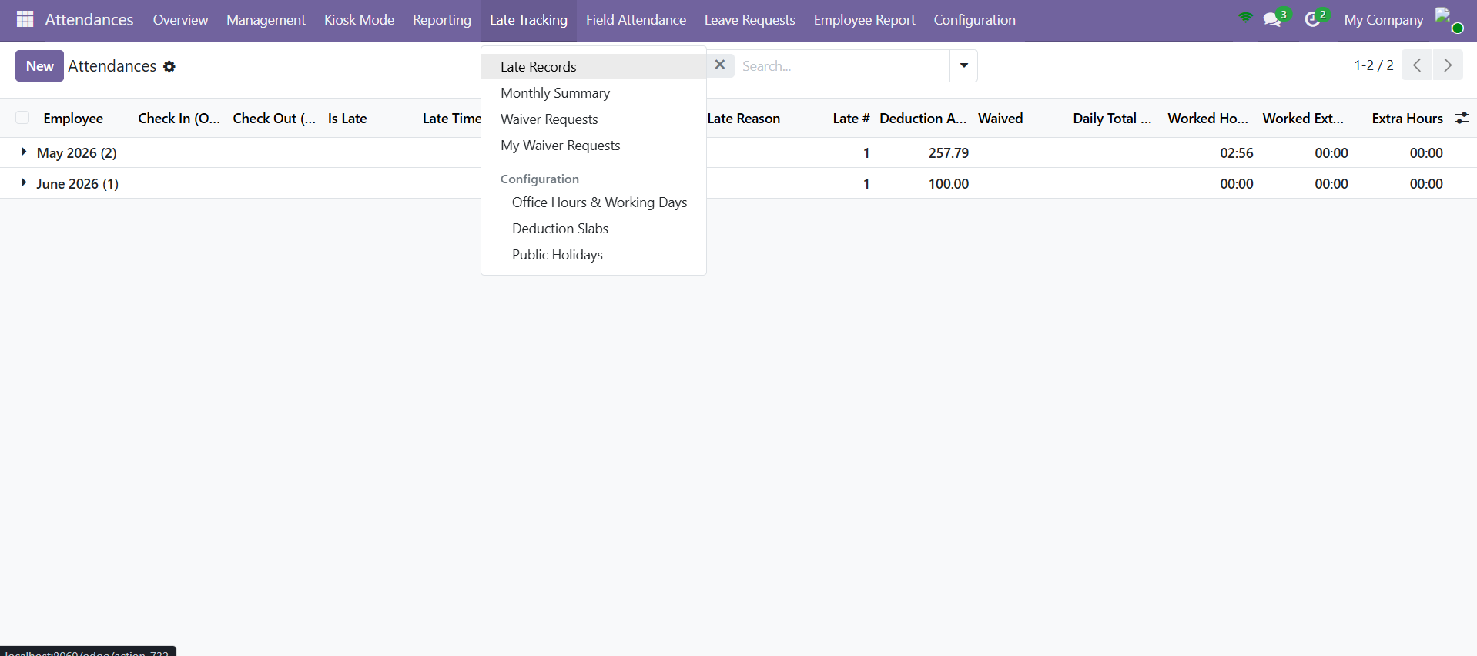
The Late Tracking menu — Late Records, Monthly Summary, Waiver Requests and the Configuration group.

PART 2 CONFIGURING THE LATE POLICY

Set the policy up once. The central screen is Office Hours & Working Days; two supporting screens define the slab amounts and the holiday calendar.
2 | Set Office Hours & Working Days

Open Configuration → Office Hours & Working Days. Each record defines the policy for a company, optionally narrowed to one Department, in a chosen Office Timezone.
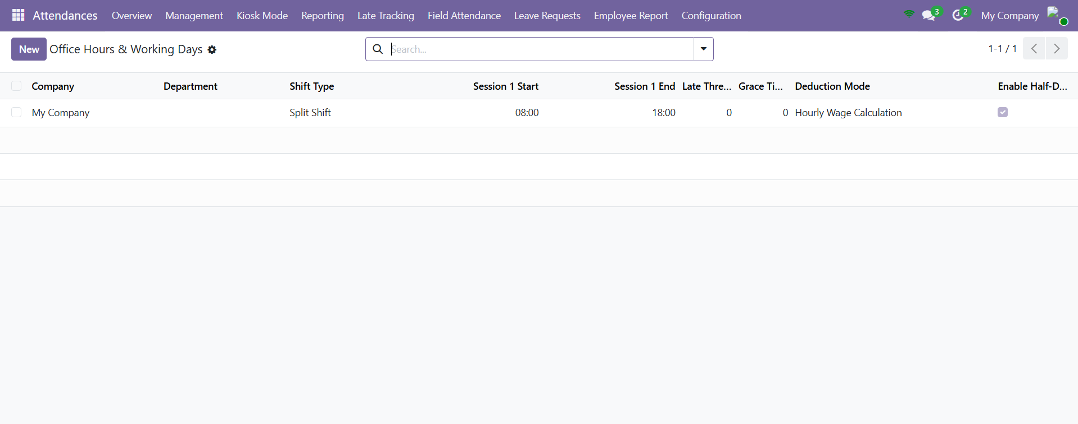
Office Hours & Working Days — the policy record list, showing shift type, hours and deduction mode.
- Scope — Company, optional Department, Office Timezone (e.g. Asia/Muscat).
- Late Settings — Late Threshold (minutes) and Grace Late Times/Month.
- Shift Type — Single Shift (Session 1 only) or Split Shift (Session 1 + Session 2).
- Office Hours — the Start and End time for each session.
- Working Days — tick the days the company actually works.
- Half-Day Friday — enable it, set which Fridays (e.g. 2,4) and the shorter hours.

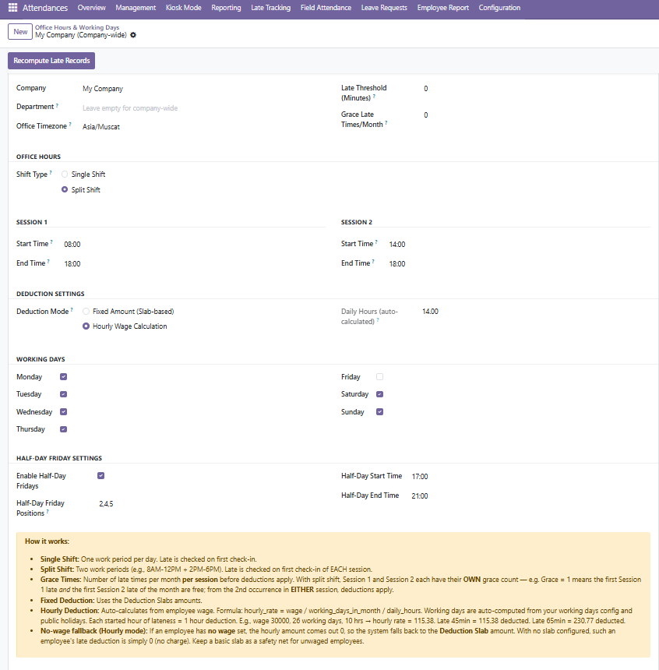
- Trip Deviation Check — Trip KM Tolerance (default 5 km) and Trip Time Tolerance (Minutes) (default 10) set how far a field trip may exceed its Estimated KM / Time before it is flagged “Over — Check”, which forces the driver to enter a Deviation Reason.

The full configuration form — scope, late settings, sessions, deduction mode, working days and half-day Fridays, with the Recompute Late Records button at the top.
TIP Use the Recompute Late Records button after changing the policy so existing records pick up the new office hours, grace and slabs.

3 | Choose a Deduction Mode

Two modes decide how much is deducted once an employee is past their grace quota. Pick the one that matches your payroll rules.
Deduction mode | How the amount is worked out
Fixed Amount (Slab-based) | The late minutes are matched to a row in the Deduction Slabs table and that fixed amount is charged.
Hourly Wage Calculation | An hourly rate (wage ÷ working days ÷ daily hours) is charged for each started hour late. Falls back to the slab if the employee has no wage.

4 | Set up Deduction Slabs

Open Configuration → Deduction Slabs. Each row is a minute range — Late From and Late To (set To = 0 for “and above”) — with a Deduction Amount. These are used directly in Fixed mode, and as a fallback in Hourly mode.
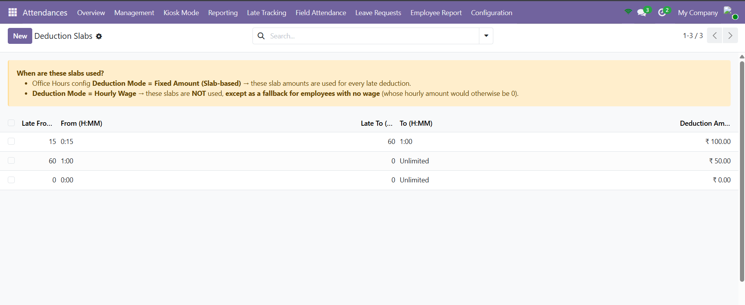
Deduction Slabs — each minute range and its fixed amount (To = 0 means “and above”).
5 | Maintain Public Holidays

Open Configuration → Public Holidays and add each holiday with a Name and Date. Holidays are removed from the working-days count, so no one is marked late on a day off.
NOTE The grace quota is counted per session, per month. With a split shift, the first late arrival in Session 1 and the first in Session 2 each use their own free allowance before any deduction applies.

PART 3 WORKING WITH LATE RECORDS

6 | Read a late record

Open Late Tracking → Late Records. Each check-in shows whether it Is Late, the Late Time (H:MM), the Session, whether it is a Half Day, the Late # in the month, the Deduction Amount and whether it was Waived. Use the Late Only, With Deduction, Missing Reason and group-by filters to focus. The Late Reason now appears as a column by default, so the explanation is visible without opening each record.
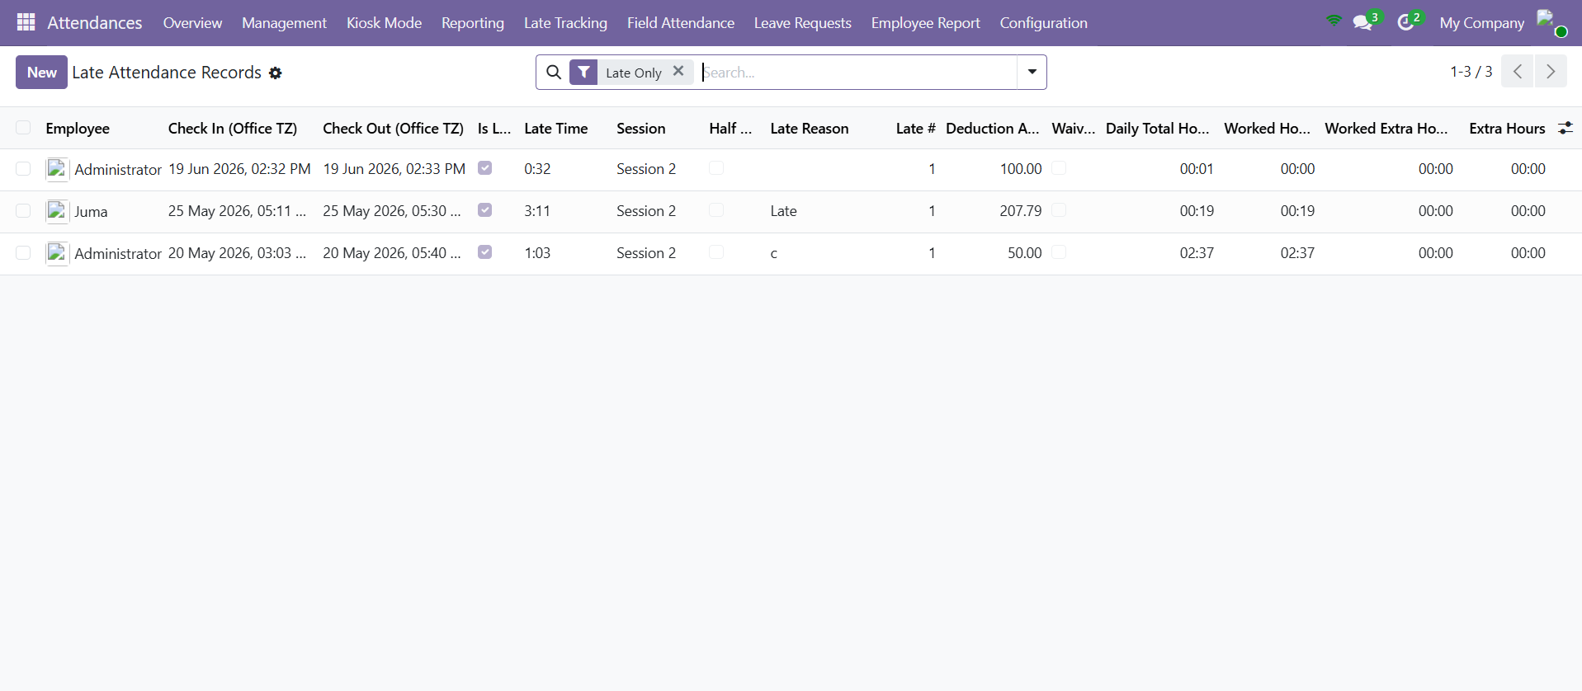
Late Records with the Late Only filter — late time, session, late #, deduction and waiver status per check-in.
7 | Enter a late reason

On a late attendance, click Enter Late Reason in the Late Tracking section and type the explanation, or type straight into the Late Reason field. The button is hidden once a reason is filled or the record is waived. Before you save, the pop-up previews the late time, the session, the expected start, the Late # in the month and the Deduction amount, so you can see exactly what will be deducted. Once a reason is saved the button changes to Update Reason (click it to edit the wording), and the button is also hidden after check-out.

PART 4 THE LATE WAIVER WORKFLOW

A waiver lets a manager cancel a late deduction when the lateness was justified. It moves through a simple, audited set of states.
8 | Submit a waiver (employee)

On a late record, raise a waiver request, fill the Reason for Waiver and click Submit for Approval. The request moves from Draft to Pending Approval.
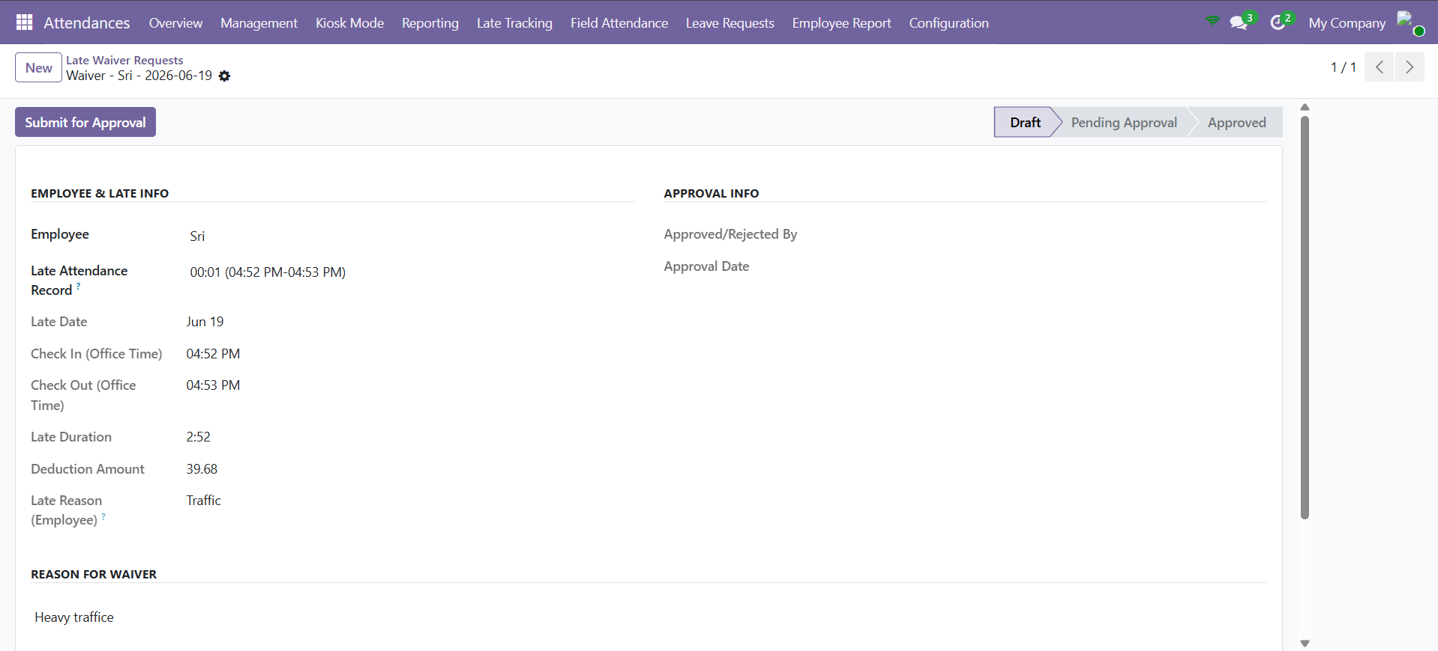
A waiver request in Draft — employee and late details, reason for waiver, and the Submit for Approval button.
9 | Approve or reject (manager)

A manager opens the pending request and clicks Approve Waiver — the attendance is marked waived and its deduction becomes zero — or Reject with a note. A rejected request can be reset to Draft and resubmitted.
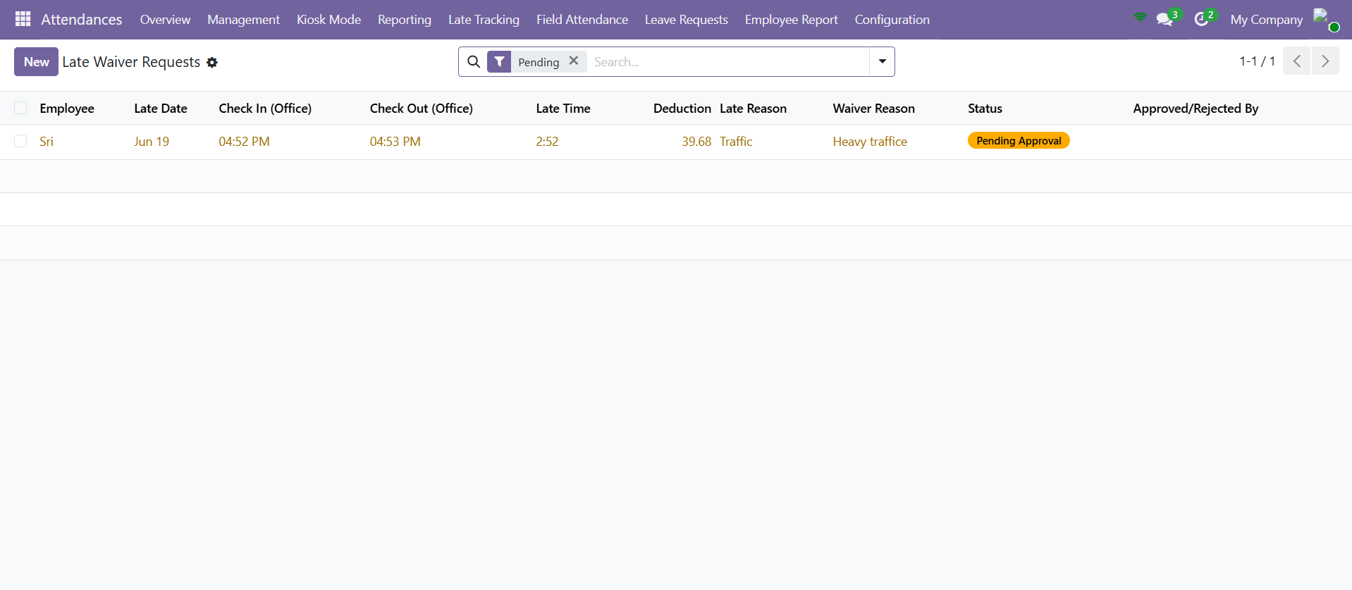
Waiver Requests — a request awaiting manager approval (Pending Approval).
State | Meaning | Who acts / button
Draft | Being prepared. | Employee — Submit for Approval
Pending Approval | Waiting on a manager. | Manager — Approve Waiver / Reject
Approved | Deduction waived (set to zero). | —
Rejected | Declined, with a reason. | Employee — Reset to Draft

PART 5 THE MONTHLY LATE SUMMARY REPORT

10 | Generate the summary

Open Late Tracking → Monthly Summary. Choose the Month and Year, optionally a Department or specific Employees, then click Generate Summary.
11 | Read the summary

The report lists one row per employee with Total Late Days, Total Late Time (H:MM) and Total Deductions. Only late arrivals beyond the grace quota are counted — free late times are not in the totals — so the figures match what payroll should deduct.
IMPORTANT The summary always counts only the late occurrences after the monthly grace quota, and never counts waived records, so it never over-deducts.

Quick Reference — Menus & Buttons
Where | What it does
Office Hours & Working Days | Define office hours, grace, shift type, working days and half-day Fridays.
Deduction Slabs | Set the fixed amounts charged for each late-minute range.
Public Holidays | Keep the holiday calendar so days off never count as late.
Late Records | Review every check-in, the late time and the deduction.
Enter Late Reason | Record why an employee was late.
Waiver Requests | Submit, approve or reject a waiver of a late deduction.
Monthly Summary | Generate the per-employee late totals for payroll.
Recompute Late Records | Reapply the policy after a configuration change.

Things to Remember
- Set Office Hours, grace and deduction mode before anything else — everything builds on them.
- Grace is per session, per month; deductions start only after it is used up.
- Keep Public Holidays current so no one is flagged late on a day off.
- Recompute Late Records after any policy change.
- Approved waivers zero the deduction; the monthly summary never counts waived or in-grace records.
- A late check-in cannot be saved in the backend without a Late Reason — enter it through the Enter Late Reason pop-up first (waived records are exempt).
- Trip KM / Time Tolerances decide when a field trip is flagged Over — Check; raise them to allow bigger deviations before a reason is required.

— End of Guide —
369ai.Biz | Attendance Late Tracking — HR Guide

